FACULTY OF TECHNOLOGY AND ENGINEERING

B.Tech. (CSE / CE / IT / AIML)

Semester III | Academic Year 2026–27

CSUC201 – Fundamentals of Data Structure and Algorithms

PRACTICAL EXAMINATION

Maximum Marks 50.

Questions to Attempt 2.

Q1-25 Marks, Q2-25 Marks

ID : 25dce118

Instructions

1. Attempt ONE option from Question 1 and ONE option from Question 2.

2. Each question carries 25 marks.

3. The examination is completely programming-based. No theoretical answer, algorithm description,

pseudocode, or written explanation is required.

4. Students must demonstrate the program using suitable normal, boundary, and exceptional test cases.

5. Appropriate functions must be created for major operations.

6. Built-in library functions that directly perform the required ordering, searching, or linked-list

operations are not permitted.

7. For Question 2, use dynamically allocated nodes. STL list or similar ready-made linked containers are

not permitted.

8. The student must identify and implement the most appropriate solution from the problem

Requirements

Q1(B) – Inter-College Hackathon Result Processor :

An inter-college hackathon stores Team_ID and Final_Score for every participating team. Team_ID is

unique, while different teams may obtain the same score. The result system must generate the final

ranking and answer result-related queries.

Develop a program that performs the following:

1. Read records of N teams.

2. Create the final ranking using these rules: higher score receives the better rank; if two teams have

the same score, the smaller Team_ID appears first.

3. Display the complete ranked list as Rank, Team_ID, and Score.

4. Identify every score obtained by more than one team and display the score with the number of

teams obtaining it.

5. Accept Q result queries. Each query contains a Team_ID. Display Team_ID, Score, and Final Rank, or

display Team Not Found.

6. Implement two different ways of locating a requested team using ideas covered in the practical

syllabus.

7. Count the number of record comparisons made by both implementations while processing all Q

queries.

8. At the end, automatically display total comparisons for both methods and identify the better method

for this input.

9. Correctly handle one team, equal scores, already ranked input, reverse-ranked input, highest/lowest

scoring teams, and invalid Team_ID queries.

Solution code :

#include <iostream>

using namespace std;

struct Team

{

int id, score, rank;

};

void sortByRank(Team a[], int n)

{

for (int i = 0; i < n - 1; i++)

{

int best = i;

for (int j = i + 1; j < n; j++)

{

if (a[j].score > a[best].score)

best = j;

else if (a[j].score == a[best].score && a[j].id < a[best].id)

best = j;

}

swap(a[i], a[best]);

}

for (int i = 0; i < n; i++)

a[i].rank = i + 1;

}

void sortByID(Team a[], int n)
{

for (int i = 0; i < n - 1; i++)

{

int minIndex = i;

for (int j = i + 1; j < n; j++)

if (a[j].id < a[minIndex].id)

minIndex = j;

swap(a[i], a[minIndex]);

}

}

void showDuplicateScores(Team a[], int n)

{

cout << "Duplicate Scores: ";

int found = 0;

for (int i = 0; i < n; i++)

{

int temp = 0;

for (int j = 0; j < i; j++)

if (a[i].score == a[j].score)

temp = 1;

if (temp)

continue;

int count = 0;

for (int j = 0; j < n; j++)

if (a[i].score == a[j].score)

count++;
if (count > 1)

{

cout << "Score: " << a[i].score << ", Teams: " << count << endl;

found = 1;

}

}

if (!found)

cout << "No duplicate scores\n";

}

int linearSearch(Team a[], int n, int id, int &comparisons)

{

comparisons = 0;

for (int i = 0; i < n; i++)

{

comparisons++;

if (a[i].id == id)

return i;

}

return -1;

}

int binarySearch(Team a[], int n, int id, int &comparisons)

{

comparisons = 0;

int low = 0, high = n - 1;

while (low <= high)

{

int mid = low + (high - low) / 2;
comparisons++;

if (a[mid].id == id)

return mid;

if (id < a[mid].id)

high = mid - 1;

else

low = mid + 1;

}

return -1;

}

int main()

{

int n;

cout << "Enter number of teams: ";

cin >> n;

if (n < 0)

{

cout << "Invalid input\n";

return 0;

}

if (n == 0)

{

cout << "No team records available\n";

return 0;

}

Team *teams = new Team[n];

Team *idArray = new Team[n];

cout << "Enter Team_ID and Final_Score:\n";

for (int i = 0; i < n; i++)

{

cin >> teams[i].id >> teams[i].score;

idArray[i] = teams[i];

}

sortByRank(teams, n);

cout << "\nFinal Ranking:\nRank\tTeam_ID\tScore\n";

for (int i = 0; i < n; i++)

cout << teams[i].rank << "\t" << teams[i].id << "\t" << teams[i].score << endl;

showDuplicateScores(teams, n);

sortByID(idArray, n);

int q;

cout << "\nEnter number of queries: ";

cin >> q;

int totalLinear = 0, totalBinary = 0;

for (int i = 0; i < q; i++)

{

int id;

cout << "\nEnter Team_ID to search: ";

cin >> id;
int linearComparisons, binaryComparisons;

int linearIndex = linearSearch(teams, n, id, linearComparisons);

int binaryIndex = binarySearch(idArray, n, id, binaryComparisons);

totalLinear += linearComparisons;

totalBinary += binaryComparisons;

cout << "Team_ID: " << id << endl;

if (linearIndex != -1)

{

cout << "Score: " << teams[linearIndex].score << endl;

cout << "Final Rank: " << teams[linearIndex].rank << endl;

}

else

cout << "Team Not Found\n";

cout << "Comparisons - Method 1: " << linearComparisons << endl;

cout << "Comparisons - Method 2: " << binaryComparisons << endl;

}

cout << "\nTotal Comparisons - Method 1: " << totalLinear << endl;

cout << "Total Comparisons - Method 2: " << totalBinary << endl;

if (totalLinear < totalBinary)

cout << "Better method: Method 1\n";

else if (totalBinary < totalLinear)

cout << "Better method: Method 2\n";

else

cout << "Both methods are equally efficient for this test data\n";

delete[] teams;

delete[] idArray;

return 0;

}

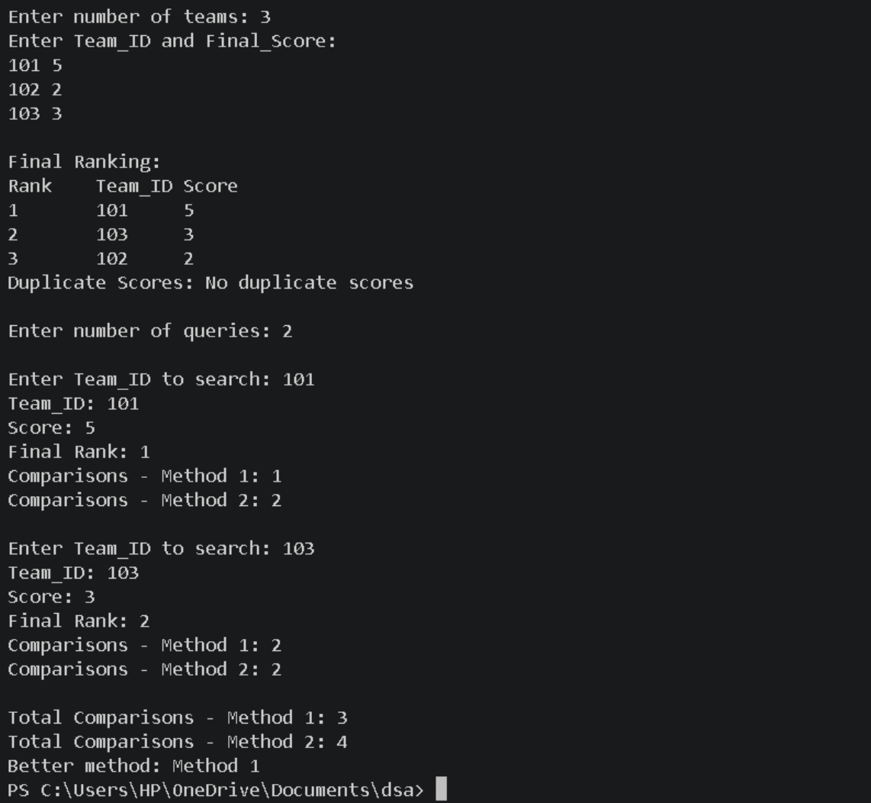
Output :

Q2(B) – Technical Support Ticket Navigator

A software company maintains active technical-support tickets dynamically. Every ticket contains

Ticket_ID and Priority, where priority is between 1 and 5. The support engineer works with one ticket

at a time and must be able to move both forward and backward through the active tickets.

New tickets must always follow this business rule: higher-priority tickets appear before lower-priority

tickets; if two tickets have the same priority, the ticket received earlier remains first.

Develop a dynamically allocated program supporting these commands:

NEW id priority – Create a new ticket and place it in its correct position.

NEXT – Move the engineer to the next ticket, if one exists.

PREVIOUS – Move the engineer to the previous ticket, if one exists.

RESOLVE id – Remove the specified ticket from the active ticket collection.

CHANGE id newPriority – Change the priority of the specified ticket and reposition it so that all

business rules remain satisfied.

SHOW – Display all active tickets from first to last as Ticket_ID and Priority.

SHOW_REVERSE – Display all active tickets from last to first.

CURRENT – Display the ticket currently selected by the engineer.

Additional Programming Requirement

Maintain a variable that counts the number of link modifications performed during every NEW,

RESOLVE, and CHANGE operation. After each such operation, display the number of link modifications.

At the end of execution, display the total number of link modifications.
The program must correctly handle:

initially empty collection and only one ticket

highest- and lowest-priority insertion

several tickets with the same priority

resolving the first, last, or current ticket

changing a ticket from low to high priority and high to low priority

invalid Ticket_ID

movement beyond the first or last ticket

Solution code :

#include <iostream>

#include <string>

using namespace std;

struct Ticket

{

int id, priority;

Ticket *next, *prev;

};

Ticket *head = NULL, *tail = NULL, *current = NULL;

long long totalMods = 0;

Ticket *findTicket(int id)

{

Ticket *temp = head;
while (temp != NULL)

{

if (temp->id == id)

return temp;

temp = temp->next;

}

return NULL;

}

int insertTicket(Ticket *node)

{

int mods = 0;

if (head == NULL)

{

head = tail = node;

}

else

{

Ticket *temp = head;

while (temp != NULL && temp->priority >= node->priority)

temp = temp->next;

if (temp == head)

{

node->next = head;

head->prev = node;
head = node;

mods = 2;

}

else if (temp == NULL)

{

node->prev = tail;

tail->next = node;

tail = node;

mods = 2;

}

else

{

Ticket *before = temp->prev;

node->next = temp;

node->prev = before;

before->next = node;

temp->prev = node;

mods = 4;

}

}

if (current == NULL)

current = node;

return mods;

}

int removeTicket(Ticket *node)
{

int mods = 0;

if (node == head && node == tail)

{

head = tail = NULL;

}

else if (node == head)

{

head = node->next;

head->prev = NULL;

mods = 1;

}

else if (node == tail)

{

tail = node->prev;

tail->next = NULL;

mods = 1;

}

else

{

node->prev->next = node->next;

node->next->prev = node->prev;

mods = 2;

}

if (current == node)
{

if (node->next != NULL)

current = node->next;

else if (node->prev != NULL)

current = node->prev;

else

current = NULL;

}

delete node;

return mods;

}

void newTicket(int id, int priority)

{

Ticket *node = new Ticket;

node->id = id;

node->priority = priority;

node->next = NULL;

node->prev = NULL;

int mods = insertTicket(node);

totalMods += mods;

cout << "Link Modifications: " << mods << endl;

}

void nextTicket()

{
if (current == NULL)

{

cout << "NO TICKET SELECTED\n";

return;

}

if (current->next == NULL)

{

cout << "NO NEXT TICKET\n";

return;

}

current = current->next;

cout << "Current Ticket: " << current->id << " Priority: " << current->priority << endl;

}

void previousTicket()

{

if (current == NULL)

{

cout << "NO TICKET SELECTED\n";

return;

}

if (current->prev == NULL)

{

cout << "NO PREVIOUS TICKET\n";

return;
}

current = current->prev;

cout << "Current Ticket: " << current->id << " Priority: " << current->priority << endl;

}

void resolveTicket(int id)

{

Ticket *node = findTicket(id);

if (node == NULL)

{

cout << "Ticket Not Found\n";

return;

}

int mods = removeTicket(node);

totalMods += mods;

cout << "Link Modifications: " << mods << endl;

}

void changeTicket(int id, int newPriority)

{

Ticket *node = findTicket(id);

if (node == NULL)

{

cout << "Ticket Not Found\n";

return;
}

int mods = removeTicket(node);

Ticket *newNode = new Ticket;

newNode->id = id;

newNode->priority = newPriority;

newNode->next = NULL;

newNode->prev = NULL;

mods += insertTicket(newNode);

totalMods += mods;

cout << "Link Modifications: " << mods << endl;

}

void show()

{

if (head == NULL)

{

cout << "NO ACTIVE TICKETS\n";

return;

}

Ticket *temp = head;

while (temp != NULL)

{

cout << "Ticket_ID: " << temp->id << " Priority: " << temp->priority << endl;

temp = temp->next;
}

}

void showReverse()

{

if (tail == NULL)

{

cout << "NO ACTIVE TICKETS\n";

return;

}

Ticket *temp = tail;

while (temp != NULL)

{

cout << "Ticket_ID: " << temp->id << " Priority: " << temp->priority << endl;

temp = temp->prev;

}

}

void showCurrent()

{

if (current == NULL)

{

cout << "NO TICKET SELECTED\n";

return;

}
cout << "Current Ticket: " << current->id << " Priority: " << current->priority << endl;

}

int main()

{

int q;

cout << "Enter number of commands: ";

cin >> q;

while (q--)

{

string command;

cin >> command;

if (command == "NEW")

{

int id, priority;

cin >> id >> priority;

newTicket(id, priority);

}

else if (command == "NEXT")

nextTicket();

else if (command == "PREVIOUS")

previousTicket();

else if (command == "RESOLVE")
{

int id;

cin >> id;

resolveTicket(id);

}

else if (command == "CHANGE")

{

int id, priority;

cin >> id >> priority;

changeTicket(id, priority);

}

else if (command == "SHOW")

show();

else if (command == "SHOW_REVERSE")

showReverse();

else if (command == "CURRENT")

showCurrent();

}

cout << "Total Link Modifications: " << totalMods << endl;

while (head != NULL)

{

Ticket *temp = head;

head = head->next;

delete temp;
}

return 0;

}

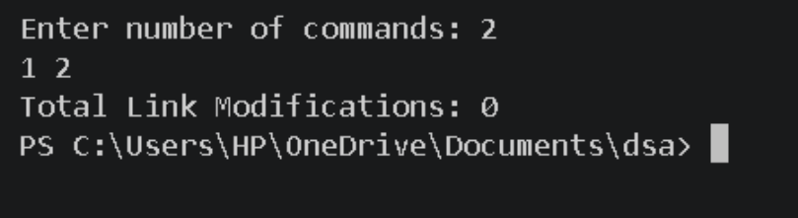
Output :

